WALEED HAMED, as the Executor of the Estate of MOHAMMAD HAMED, | Case No.: SX-2012-CV-370
Plaintiff/Counterclaim Defendant,
vs.  FATHI YUSUF and UNITED CORPORATION | ACTION FOR DAMAGES, INJUNCTIVE RELIEF AND DECLARATORY RELIEF
Defendants and Counterclaimants.  vs.  WALEED HAMED, WAHEED HAMED, MUFEED HAMED, HISHAM HAMED, and PLESSEN ENTERPRISES, INC.,  Counterclaim Defendants, | JURY TRIAL DEMANDED
 | Consolidated with
WALEED HAMED, as the Executor of the Estate of MOHAMMAD HAMED, Plaintiff,  vs. | Case No.: SX-2014-CV-287
UNITED CORPORATION, Defendant.
WALEED HAMED, as the Executor of the Estate of MOHAMMAD HAMED, Plaintiff  vs.  FATHI YUSUF, Defendant. | Consolidated with  Case No.: SX-2014-CV-278
FATHI YUSUF, Plaintiff,  vs.  MOHAMMAD A. HAMED TRUST, et al,  Defendants. | Consolidated with  Case No.: ST-17-CV-384
KAC357 Inc., Plaintiff,  vs.  HAMED/YUSUF PARTNERSHIP,  Defendant. | Consolidated with  Case No.: ST-18-CV-219

HAMED MOTION TO COMPEL NO. 3 OF 5 WITH REGARD TO THE “B(1)” CLAIMS

AS TO: REVISED YUSUF CLAIM H-142 – HALF ACRE IN ESTATE TUTU

- Introduction

The parties must file a motions to compel related to the B(1) group of claims. Hamed is filing the fthird of those motions to compel defendants to respond to interrogatories and requests for the production of documents as they relate Hamed revised claim H-142 – Half Acre in Estate Tutu presently in United’s possession.

It should be noted, however, that Hamed has been attempting to procure responses to these specific requests from both Yusuf and United since May 15, 2018 without success. Hamed respectfully requests that the Master order responses to this long outstanding discovery.

Such discovery is necessary because the Hamed/United Partnership provided $330,000 to Plessen Enterprises, Inc. (“Plessen”, a Hamed/United 50/50 corporation) – from the D/B/A Plaza Extra Supermarket account -- to purchase a 0.536 acre parcel. This amount from the Partnership account was 100% of the purchase price. Not a single cent for this land came from Yusuf personally or from the separate United Corporate (Tenant) Account. Thus, Hamed asserts that, pursuant to RUPA, that this is partnership property.

The parcel is adjacent to and provides access to a larger, 9.438 acre, parcel that the Partners owned, and intended to use to build a Plaza Extra Supermarket in Tutu – so that Plaza would not have to rent the present Tutu premises.

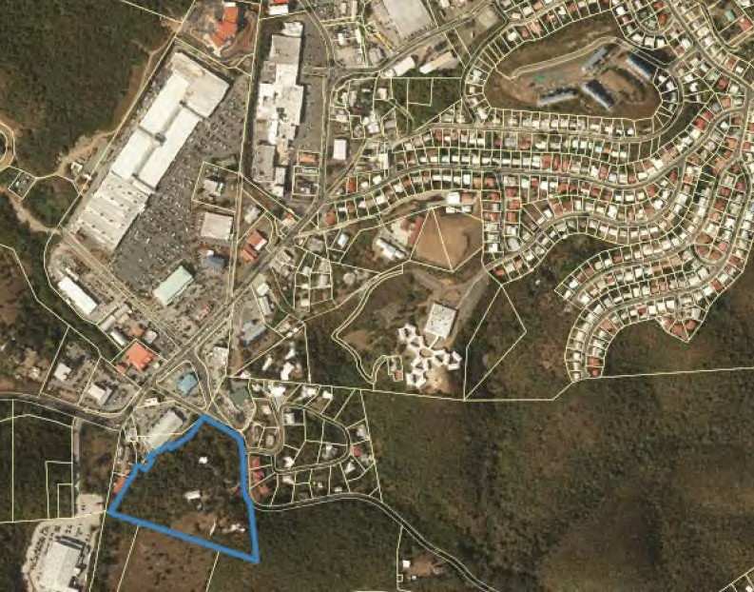
Parcel
Acre
9.438
MALL
TUTU
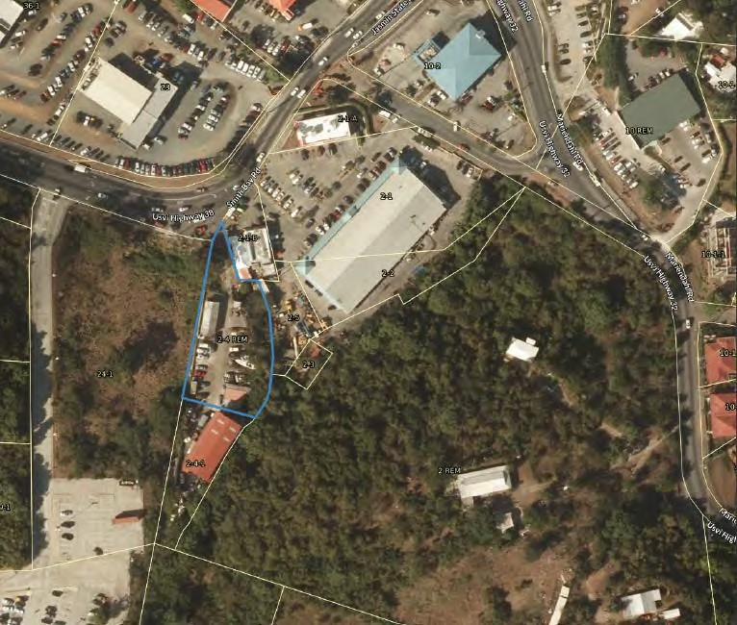
Parcel
Acre
9.438
Subject
0.536
Acre celll
Route 38

United obtained this title after the bar date in this action. United “foreclosed” on the parcel in a no-consideration proceeding, where United had never contributed a cent. This occurred because, in 2008, at a time when the Partners were under federal criminal charges for skimming supermarket profits away from the Partnership, Fathi United was “moving” around title in some of those properties to accommodate that criminal situation. Both Fathi United and the Hameds have recently admitted that neither Plessen nor United provided a single cent in consideration for this land – it was 100% Partnership funds. Thus, the United “explanations” as to the factual landscape of what was what happening surrounding the time of the original purchase and at the time of the post-bar foreclosure are critical.
- Procedural Status
On February 26, 2018, United filed a motion to strike Hamed’s revised claims H-142 (this claim) and H-143. On March 5, 2018 Hamed filed his opposition and on March 20, 2018 United filed his reply. On July 11, 2018, the Master denied United’s motion to strike revised claim H-142 and ordered “[d]iscovery in connection with Hamed Claim No. H-142 shall be completed no later than August 10, 2018.” (Exhibit 1, at p. 11)
On August 4, 2018, the Master signed a Scheduling Order which allowed the parties to engage in discovery “outside of the deadlines established by the [Discovery Plan] as long as the discovery was completed before the dispositive motion deadline.” (Exhibit 2, at p. 2) The parties engaged in discovery pursuant to that Scheduling Order. After the majority of the discovery was produced on May 15, 2018, the parties entered into a series of letters and Rule 37 conferences to resolve their differences. The following motion pertains to Hamed revised claim H-142 – Half Acre in Estate Tutu.
- Facts
- United and Yusuf failed to answer Hamed’s Interrogatory 21 of 50

On February 21, 2018, Hamed propounded the following interrogatory:
Interrogatory 21 of 50:

Interrogatory 21 of 50 relates to Claim No. H-142 (old Claim No. 490): “Half acre in Estate Tutu,” as described in Hamed’s November 16, 2017 Motion for a Hearing Before Special Master, Exhibit 3 and the September 28, 2016 JVZ Engagement Report and Exhibits.

With respect to Claim No. H-142, state in detail how this half acre in Estate Tutu was purchased and what funds were used, the source of those funds and any discussions or agreements about the funds or the purchase, with reference to all applicable documents, communications and witnesses. (Exhibit 3)

On May 15, 2018, United/Yusuf refused to respond to interrogatory 21 – stating that there would be no response because United’s had filed a pending motion to strike, and it was United’s unilateral view that this claim was outside of Judge Brady’s Limitation Order.
United Response to Interrogatory 21 of 50:

Defendants object to this Interrogatory because it involves a potential claim that is barred by the Court's Memorandum Opinion and Order Re Limitation on Accounting ("Limitation Order"), which limits the scope of the accounting to only those transactions that occurred on or after September 17, 2006. Pursuant to a deed dated July 26, 2006 and recorded on August 24, 2006, this property was titled in the name of Plessen Enterprises, Inc. and was not an asset of the Partnership as of September 17, 2006. Accordingly, any claims by Hamed relating to this property are clearly barred by the Limitation Order and Defendants have no obligation to provide discovery concerning a barred claim because "the proposed discovery is not relevant to any party's claim or defense." V.I. R. Civ. P. 26(b)(2)(C)(iii).

Moreover, this claim is the subject of Defendants' Motion to Strike Hamed's Amended Claim Nos. 142 and 143 ("Motion to Strike") seeking to strike Hamed Claim 142 on the grounds that the property was titled in the name of Plessen, was not an asset of the Partnership and is barred by the Limitation Order. Defendants incorporate by reference their Motion to Strike as if fully set forth herein verbatim and submit that because there is a pending Motion to Strike, the requirement for a response should be stayed pending the resolution. (Exhibit 4)
On July 11, 2018, in response to United’s motion to strike H-142, the Master denied the motion to strike and ordered “[d]iscovery in connection with Hamed Claim No. H-142 shall be completed no later than August 10, 2018.” (Exhibit 1, at p. 11)(Emphasis added).
On July 12, 2018, Hamed’s attorney requested that United respond to Hamed’s Interrogatory 21 (“ROG 21”), request for production of documents 13 (“RFPDs 13”) and request for admissions 22 (“RTA 22”) in response to the Master’s July 11, 2018 Order. (Exhibit 5) As no discovery responses were forthcoming, on July 17, 2018, Hamed’s attorney sent a follow up letter to United’s attorney requesting responses to Hamed’s ROG 21, RFPDs 13 and RTA 22. (Exhibit 6) On July 19, 2018, Hamed’s attorney sent a formal request for a Rule 37 conference to United’s attorney, as, once again, no discovery responses had been submitted by United. (Exhibit 7)
Subsequent to Hamed’s July 19, 2018 letter, later on July 19, 2018, United propounded supplemental discovery responses. With respect to ROG 21, United stated:

Supplemental Response

Defendants show that all documents relating to the purchase of the half acre in Estate Tutu are those documents, which have already been provided in this case including the Warranty Deed and the First Priority Mortgage. Further responding, Defendants show that Mr. Yusuf is out of the country until August 18, 2018 and to the extent that any additional information is required of him, Defendants are unable to provide that information at this time, but will readily supplement as soon as he is available. (Exhibit 8) (Emphasis added).

On October 15, 2018, Hamed’s counsel sent another letter to United’s counsel, outlining the deficiency in United’s supplemental response:

Please supplement your response, including identifying how this half acre in Estate Tutu was purchased and what funds were used, the source of those funds and any discussions or agreements about the funds or the purchase, with reference to all applicable documents, communications and witnesses. (Exhibit 9)

A meet and confer was held on November 9, 2018. Another meet and confer was held on November 12, 2018. In a November 20, 2018 letter summarizing the agreements that came out of the November 9, 2018 Rule 37 conference, United’s counsel agreed “to answer this interrogatory by December 15, 2018.” (Exhibit 10)
On December 18, 2018, United did not respond at all to Interrogatory 21, unilaterally deciding that responding to the interrogatory was not required as the claim was to be considered after August 30, 2019. (Exhibit 11) A third Rule 37 conference was set for 11 a.m. on Thursday, December 20, 2018 to discuss this matter. (Exhibit 12) United’s counsel did not appear and did not provide any written or other notice of non-appearance.
- Similarly, United fails to answer Hamed’s RFPDs No. 13 of 50

RFPDs 13 of 50

Request for the Production of Documents,13 of 50, relates to H-142 (old Claim No. 490): “Half acre in Estate Tutu.”

With respect to H-142, please provide all documents which relate to this entry -- particularly (but not limited to) all underlying documents relating to the source of funds for the purchase of this property if it was other than income from the stores. (Exhibit 13)

United’s Response to RFPDs 13 of 50

Defendants object to this Request for Production because it involves a potential claim that is barred by the Court's Memorandum Opinion and Order Re Limitation on Accounting ("Limitation Order"), which limits the scope of the accounting to only those transactions that occurred on or after September 17, 2006. Pursuant to a deed dated July 26, 2006 and recorded

on August 24, 2006, this property was titled in the name of Plessen Enterprises, Inc. and was not an asset of the Partnership as of September 17, 2006. Accordingly, any claims by Hamed relating to this property are clearly barred by the Limitation Order and Defendants have no obligation to

provide discovery concerning a barred claim because "the proposed discovery is not relevant to any party's claim or defense." V.I. R. Civ. P. 26(b)(2)(C)(iii).

Moreover, this claim is the subject of Defendants' Motion to Strike Hamed's Amended Claim Nos. 142 and 143 ("Motion to Strike") seeking to strike Hamed Claim 142 on the grounds that the property was titled in the name of Plessen, was not an asset of the Partnership and is barred by the Limitation Order. Defendants incorporate by reference their Motion to Strike as if fully set forth herein verbatim and submit that because there is a pending Motion to Strike, the requirement for a response should be stayed pending the resolution. (Exhibit 14)

On July 11, 2018, in response to United’s motion to strike H-142, the Master denied the motion to strike and ordered “[d]iscovery in connection with Hamed Claim No. H-142 shall be completed no later than August 10, 2018.” (Exhibit 1, at p. 11)
On July 12, 2018, Hamed’s attorney requested that United respond to Hamed’s Interrogatory RFPDs 13 in response to the Master’s July 11, 2018 Order. (Exhibit 5) As no discovery response was forthcoming, on July 17, 2018, Hamed’s attorney sent a follow up letter to United’s attorney requesting a response to Hamed’s RFPDs 13. (Exhibit 6)
Subsequent to Hamed’s letter, later on July 19, 2018, United propounded supplemental discovery responses. With respect to RFPDs 13, United stated:

Supplemental Response

Defendants show that all documents in their possession, custody or control have already been produced (warranty deed, first priority mortgage, and deed in lieu of foreclosure with accompanying tax clearance letter from Mohammad Hamed. Further responding, Defendants show that there are no documents responsive to this request to the extent it seeks documents reflecting sources of funds for the purchase other than income from the stores. (Exhibit 15)

A meet and confer was held on November 9, 2018. Another meet and confer was held on November 12, 2018. In a November 20, 2018 letter summarizing the agreements that came out of the November 9, 2018 Rule 37 conference, United’s counsel agreed “to answer this request for production of documents by December 15, 2018.” (Exhibit 16)
December 18, 2018, United did not respond at all to RFPDs 13, unilaterally deciding that responding to the request was not required as the claim was to be considered after August 30, 2019. (Exhibit 11) A third Rule 37 conference was set for 11 a.m. on Thursday, December 20, 2018 to discuss this matter. (Exhibit 12) United’s counsel did not appear and did not provide any written or other notice of non-appearance.
- Argument
This Motion to Compel is submitted pursuant to the Joint Discovery and Scheduling Plan of January 29, 2018.
- Rule 26 Duty to Disclose; General Provisions Governing Discovery
Rule 26 of Virgin Islands Rules of Civil Procedure (“Rule 26”) is the foundational rule governing discovery. It broadly allows discovery regarding “any nonprivileged matter that is relevant to any party’s claim or defense. Information within this scope of discovery need not be admissible in evidence to be discoverable.” V.I. R. CIV. P. 26(b)(1), emphasis added.
- United refuses to respond to Hamed’s interrogatory no. 21

Rule 33 of the Virgin Islands Rules of Civil Procedure (“Rule 33”), among other things, identifies the duties of the party responding.
- Answers and Objections.
* * * *
(3) Answering Each Interrogatory. Each interrogatory must, to the extent it is not objected to, be answered separately and fully in writing under oath.
(4) Objections. The grounds for objecting to an interrogatory must be stated with specificity. Any ground not stated in a timely objection is waived unless the court, for good cause, excuses the failure.

United has completely refused to respond to this interrogatory. This discovery is necessary for Hamed to prosecute his claim with respect to the half-acre parcel in Estate Tutu, particularly since United alleges that this property “belongs” to United and not the Partnership – despite the bald admission that it was purchased solely with Partnership funds and neither Plessen nor United every contributed a single cent to its purchase or upkeep. (Exhibits 15 and 17) Hamed respectfully requests that United be required to respond to the following:
- Discuss how the half-acre in Estate Tutu was purchased, for example, why the parcel was purchased, what the benefits from the purchase were.
- Identify the source of funds used to purchase the half-acre in Estate Tutu.
- Identify any funds ever paid for the parcel, at the time of purchase or any other time, including the time of the “foreclosure” by United AFTER Judge Brady’s SOL/laches date in 2006.
- Provide information regarding any discussions or agreements about the funds or the purchase, including a detailed list of the documents and witnesses to the discussions or agreements with regard to the initial purchase or eventual foreclosure. Additionally, describe any communications about the funds or purchase of the land or eventual foreclosure.

- Similarly, United refuses to respond to Hamed’s document request no. 13

Rule 34 of the Virgin Islands Rules of Civil Procedure (“Rule 34”), among other things, identifies the scope of the document production and the duties of the party responding.
(a) In General. A party may serve on any other party a request within the scope of Rule 26(b): (1) to produce and permit the requesting party or its representative to inspect, copy, test, or sample the following items in the responding party's possession, custody, or control: (A) any designated documents or electronically stored information. . .

United has refused to identify the documents in his control regarding RFPDs 13. Instead, United said the following have already been produced: a warranty deed, first priority mortgage, and deed in lieu of foreclosure with accompanying tax clearance letter from Mohammad Hamed. At a minimum, with all the discovery that has gone back and forth between the parties, United should identify the bates numbers of those documents he listed that have already been produced. Further, he should produce any other documents that may relate to this claim, such as general ledgers, tax documents and bank records related to the purchase, the mortgage and the transfer into United’s name in 2008. Any correspondence, letters, faxes or other communications related to the half-acre parcel, whether it relates to the purchase, sale, rationale for acquiring the property, reason for the mortgage and the transfer into United’s name should also be produced.
Hamed needs a response to this request in order to fully support his claim that the land is a Partnership asset.
- Conclusion
All of Hamed’s interrogatories and request for documents discussed above clearly fall within Rule 26’s scope allowing discovery regarding “any nonprivileged matter that is relevant to any party’s claim or defense.” (Emphasis added). Hamed has patiently been trying to get responses to this discovery since May 15, 2018, with no success. Accordingly, Hamed respectfully requests that the Master compel United to answer and produce the following:
Interrogatory 21 of 50

- Discuss how the half-acre in Estate Tutu was purchased, for example, why the parcel was purchased, what the benefits from the purchase were.
- Identify the source of funds used to purchase the half-acre in Estate Tutu.
- Identify any funds ever paid for the parcel, at the time of purchase or any other time, including the time of the “foreclosure” by United AFTER Judge Brady’s SOL/laches date in 2006.
- Provide information regarding any discussions or agreements about the funds or the purchase, including a detailed list of the documents and witnesses to the discussions or agreements with regard to the initial purchase or eventual foreclosure. Additionally, describe any communications about the funds or purchase of the land or eventual foreclosure.

RFPDs 13 of 50

- Bates numbers referencing the documents United states have already been produced: a warranty deed, first priority mortgage, and deed in lieu of foreclosure with accompanying tax clearance letter from Mohammad Hamed;
- All financial documents relating to this claim, such as general ledgers, tax documents and bank records related to the purchase, the mortgage and the transfer into United’s name in 2008; and
- Any correspondence, letters, faxes or other communications related to the half-acre parcel, whether it relates to the purchase, sale, rationale for acquiring the property, reason for the mortgage or transfer into United’s name.

Dated: October 2, 2019 A

Carl J. Hartmann III, Esq.

Co-Counsel for Plaintiff

5000 Estate Coakley Bay, L6

Christiansted, Vl 00820

Email: carl@carlhartmann.com

Tele: (340) 719-8941

Joel H. Holt, Esq.
Counsel for Plaintiff
Law Offices of Joel H. Holt
2132 Company Street,
Christiansted, Vl 00820
Email: holtvi@aol.com
Tele: (340) 773-8709 Fax: (340) 773-867

CERTIFICATE OF SERVICE

I hereby certify that on this 2nd day of October 2019, I served a copy of the foregoing by email (via CaseAnywhere), as agreed by the parties, on:

Hon. Edgar Ross

Special Master
% edgarrossjudge@hotmail.com

Gregory H. Hodges

Charlotte Perrell

Law House, 10000 Frederiksberg Gade
P.O. Box 756
St. Thomas, VI 00802
ghodges@dtflaw.com

Mark W. Eckard

Hamm, Eckard, LLP
5030 Anchor Way
Christiansted, VI 00820
mark@markeckard.com

Jeffrey B. C. Moorhead

CRT Brow Building
1132 King Street, Suite 3
Christiansted, VI 00820
jeffreymlaw@yahoo.com
A

CERTIFICATE OF COMPLIANCE WITH RULE 6-1(e)
This document complies with the page or word limitation set forth in Rule 6-1(e).
A
CERTIFICATE OF COMPLIANCE WITH RULE 37(a)(1)
I hereby certify that I made the required efforts in good faith to confer with counsel for United and United in order to obtain the foregoing requested information.
A

Parcel No. 2-4 Rem. Estate Charlotte Amalie, No. 3 New Quarter, St. Thomas, U.S. Virgin Islands, consisting of 0.536 acre, more or less, as shown on OLG Map No. D9-7044-T002, dated April 10, 2002.

